# Lab 3. Task 1- preparation task Template for answers

**Save this document as a .pdf document before submitting.**

*Student names and LiU-IDs: (Max 2 students per group):*

1. *Thomas Indrias (thoin216)*

*Submission date: 2018-12-7*

*Version (in case you need to re-submit): 1.0*

1. **2D Fourier spectrum**

**1)** Spec1:

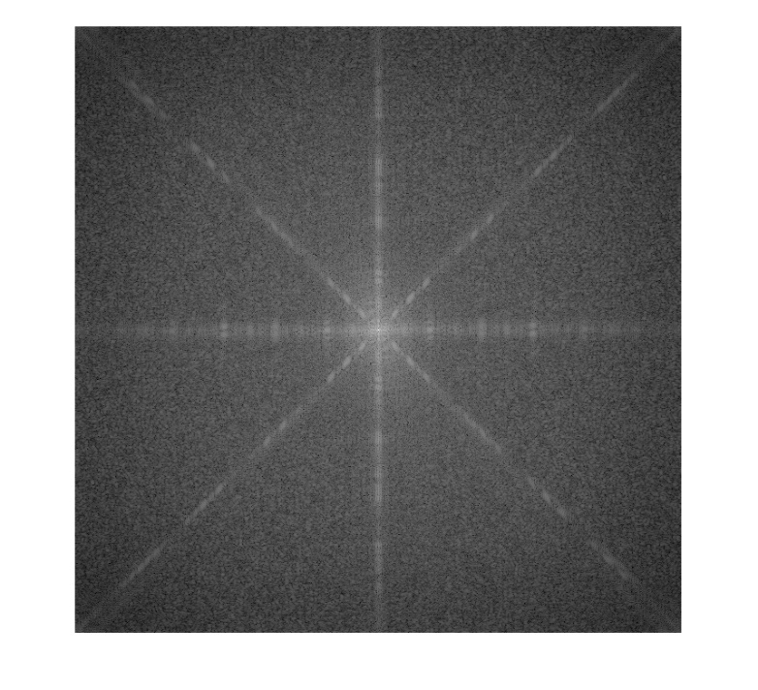

**2)** Spec2:

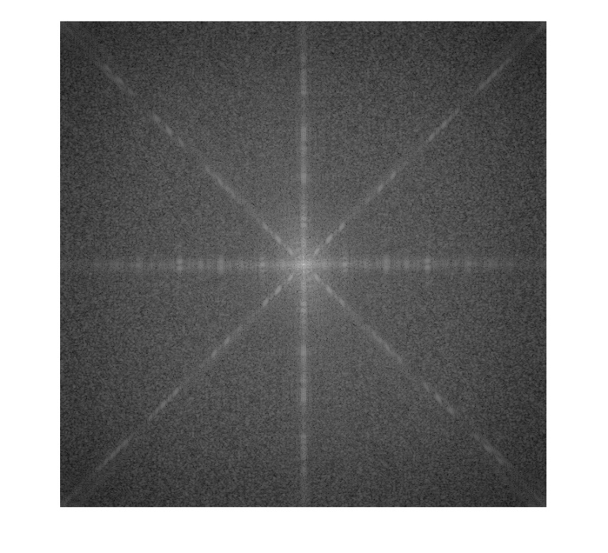

**3)** Are there any differences between and ? How does shift affect the spectrum of the Fourier transform?

%There is not a big different that can be seen. The translation has no effect on the magnitude of the spectrogram.

**4)** Spec3:

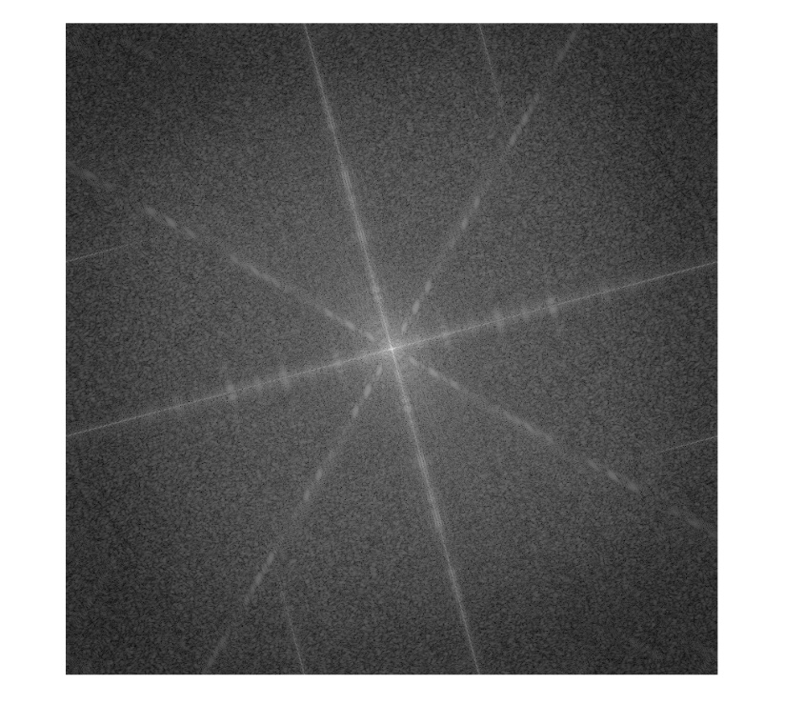

**5)** Are there any differences between and ? How does rotation in the spatial domain affect the Fourier spectrum? (Ignore some distortions caused by the black area around the image after rotation ())

% Yes, we can see that the spectrum for Spec 3 is rotated. It can be said

% that if the image is rotated, the spectrum of the image will be rotated

% with the same angle.

**6)** Spec4:

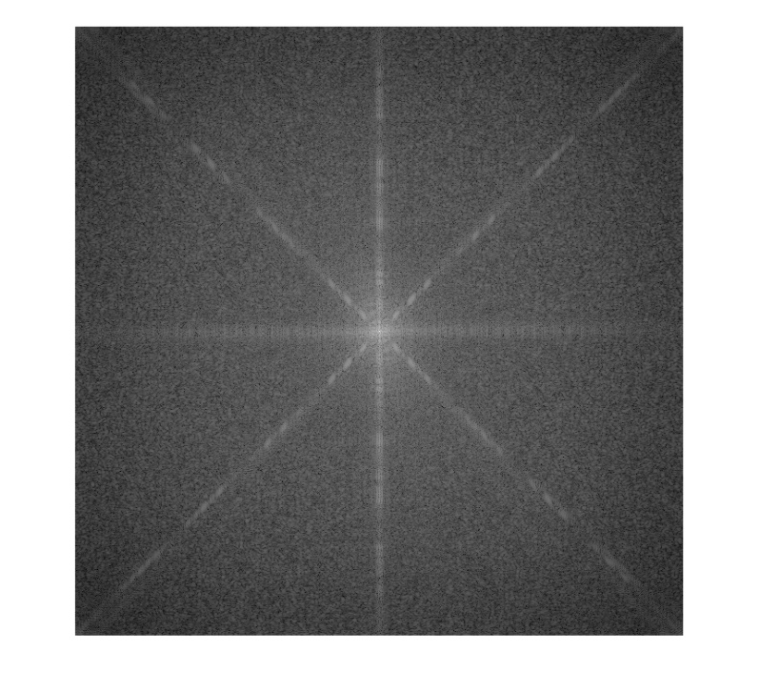

**7)** Compare and and explain how the elimination of vertical bars affected the spectrum. **HINT:** Look specially at the **horizontal** axes of the spectrum.

%The vertical lines in the image results to more detail in the horizontal

%axis (periodicity) and less in the vertical axis. This can be seen in

%Spec1 and Spec4. The spectrum, spec1 shows that there is more details in

%the horizontal axis. In spec4 (without the vertical lines in the image) we

%can see that there is less detail in the horizontal axis because there is

%no more variance from the vertical lines in the image.

**8)** Explain what would happen to the spectrum if the horizontal bars were eliminated from ?

%In this case, there would be less detail in the horizontal axis

%resulting to a spectrum with less magnitude in the vertical axis.

**9)** Spec5:

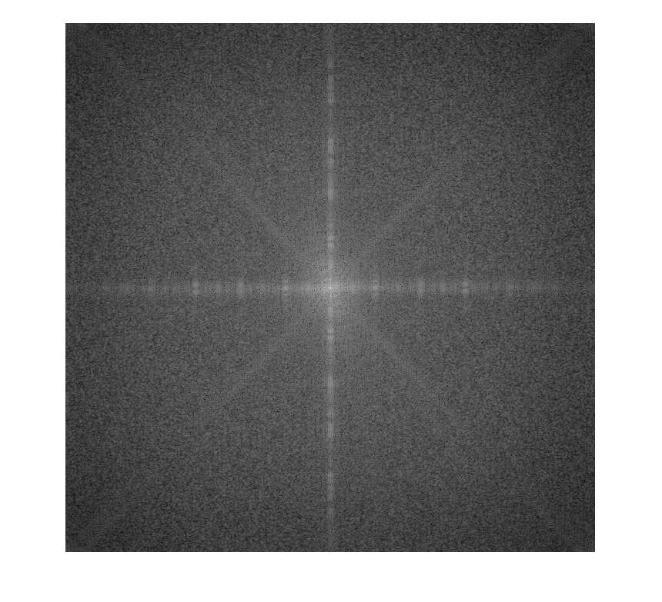

**10)** Compare and and explain how the elimination of diagonal bars affected the spectrum. **HINT:** Look specially at the diagonal axes of the spectrum.

%The same principle applies here. Since we removed the diagonal lines.

%There will be less detail in the diagonal axis in the spectrogram.

1. **Period and Frequency**

**11)** Where would these three dominant peaks appear if is transposed, i.e. if the vertical bars become horizontal?

%If we transpose, we rotate the image 90 degrees clockwise meaning that we

%will have a point on the top of the spectrum and in the centrum. Also one %on the bottom but since v2 has even size, it is not visible.

**12)** What is the frequency of these stripes? Where would the three dominant peaks in the spectrum for this image appear?

%Frequency = 0.25 cycles/pixel

%It would appear +- 1/2 from the centrum on the horizontal axis in the

%spectrum.

**13)** What is the frequency of these stripes? Where would the three most dominant peaks in the spectrum for this image appear?

%Frequency = 0.0033 cycles/pixel

%It would appear +- 1/150 from the centrum on the horizontal axis in the

%spectrum.

1. **The importance of the spectrum and the phase angle**

**14)** E1_E2:

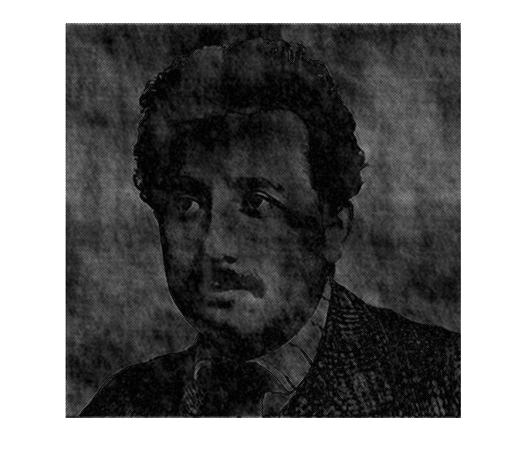

**15)** E2_E1:

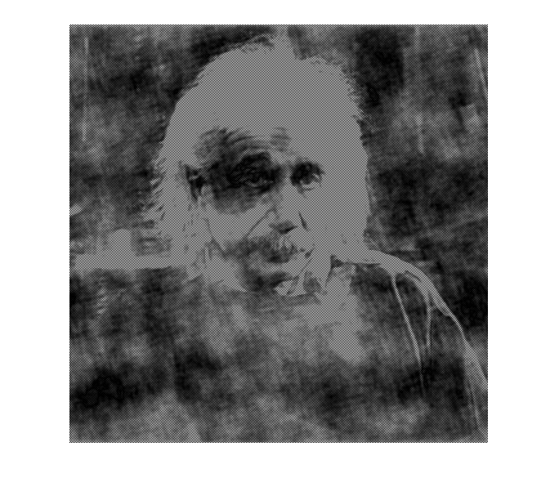

**16)** Is the spectrum or the phase angle that has more effect on the structure of an image based on your visual analysis of the above results?

%It is the phase angle that has the biggest impact on the structure which

%can be seen in the previous tasks. The image corresponding the respective

%phase angle dominates the transformed image.

*Don’t forget to save the document as* ***.pdf*** *before submitting!*